Group 9’s program

Thought process behind the game
For our programming game we wanted to make an easy-to-understand game, one which one which anyone, could pick up and understand without much issue. So, we started looking at old arcade games we could take inspiration from. After looking around, we stumbled upon Galaga and thought we could alter the game while still incorporating the main aspects of the game.
From Galaga we got the idea from having a sort of ship you control and enemy ships that you should kill/destroy. However, because we didn’t know how to implement blasters or a laser to kill from a far with consistency, we decided to make it so the player needed to ram the enemies to kill them. To make the game semi hard we added a second class of enemies that the player should be avoiding because it would cause the player to lose, this would be the substitute for the lasers the enemies shoot in Galaga.
To adhere with the scientific aspect of the challenge it was suggested that we should make it so that the game is set around blood cells and how the body fights off diseases and viruses. We therefore changed it so that you are a white blood cell trying to destroy an invasive bacteria, while avoiding healthy cells because killing them would be harmful to the body.

Instructions
To play the game first open the main menu file.
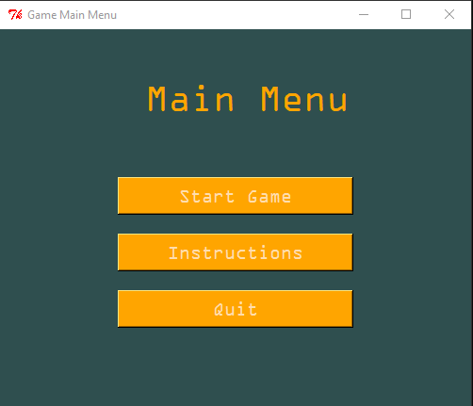
And after familiarising yourself with the instruction, Press start.
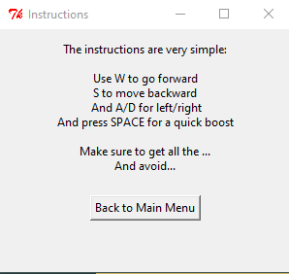
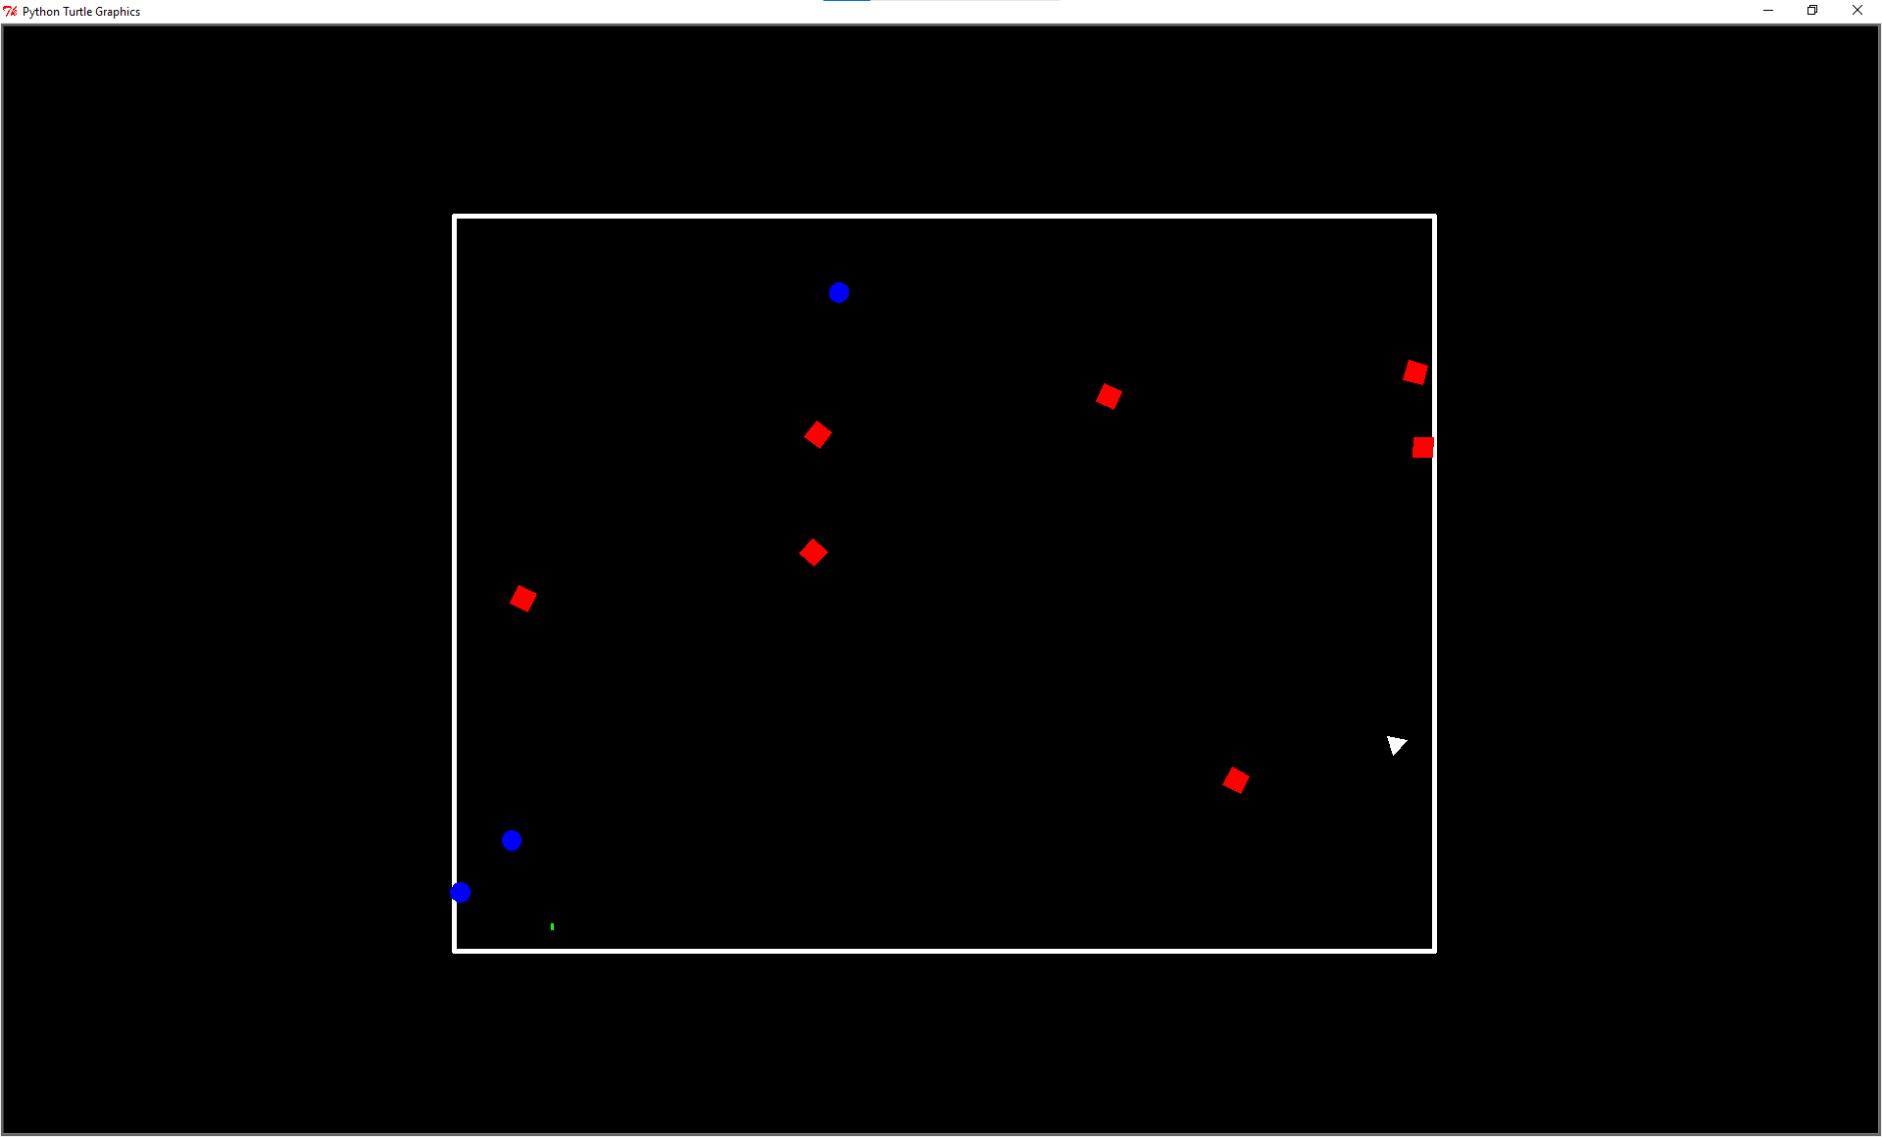
You’re the white triangle, that is on a mission to destroy all the red squares – while avoiding the blue, which give you an automatic death screen. 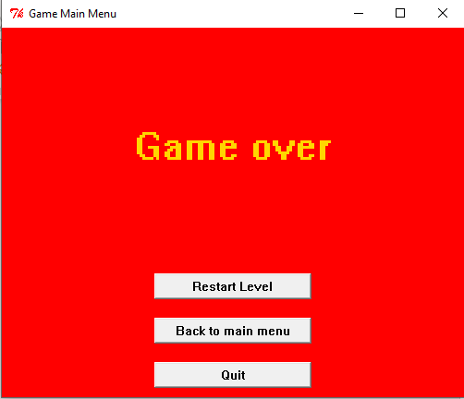
So if you do lose, don’t worry just press the restart, unless you have other plans.
But if you do manage to destroy all the red squares before being destroyed yourself
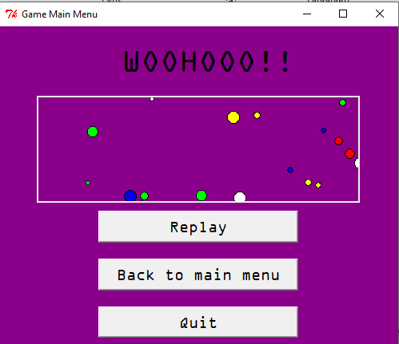
You get to the victory screen, which is meant as a congratulations for winning the game, from which you can decide to replay, go to main menu, or just quit.
**In order for the game to work, you must download/move the images Background1, Bacteria1, Redbloodcell1, whitebloodcell1, and boostbar into a new folder in Downloads names “Sprites” (without quotations)
Background image - https://wallpapercave.com/w/wp6380266
Character image – https://imgbin.com/png/AgtdZFwz/medical-icon-white-blood-cell-icon-cell-icon-png
Bacteria – https://stock.adobe.com/uk/images/bacteria-and-virus-pixel-art-set-germ-and-microbe-collection-infectious-pathogen-8-bit-sprite-game-development-mobile-app-isolated-vector-illustration/541161164
Red Blood Cells - https://www.pngaaa.com/detail/6773508
Boost bar - https://www.alamy.com/pixel-art-8-bit-retro-styled-game-design-interface-set-red-health-indicator-with-heart-blue-mana-label-with-potion-and-green-energy-loading-bar-image344194013.html?imageid=C7418169-EA9A-429C-95CA-57DAD8F361D7&p=220879&pn=1&searchId=851981655e9eaf59530e0d577c498678&searchtype=0

